Secondary 1 Name:_________________________________
Homework
14-2 Box and Whisker Plots

Find the five number summary for the following data sets and then construct a box-plot
1. {65, 63, 69, 71, 73, 59, 60, 70, 72, 66, 71, 58}

2. {31, 30, 28, 26, 22, 34, 26, 31, 47, 32, 18, 33, 26, 23, 18}

Given the five number summary: {3, 7, 11.5, 16, 39} Find:

3. What is the Range and IQR?

4. Is 39 an outlier?

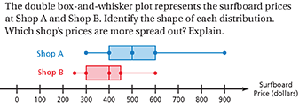
5.

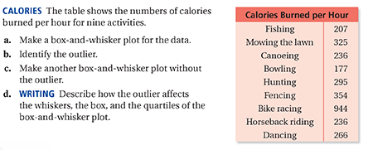
6/7

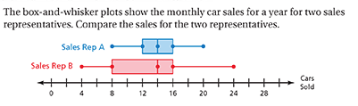
8.

Determine if the data is skewed right, skewed left, or symmetric
9. 10.

