Secondary 1 Name:_________________________________
Homework
14-1 Data displays and Measures of Central Tendency

The graduation rates from Division 1 colleges in California and Texas are shown below:
California: 64, 41, 44, 31, 37, 73, 72, 68, 35, 37, 81, 90, 82, 74, 79, 67, 66, 66, 70, 63
Texas: 67, 21, 32, 88, 35, 71, 39, 35, 71, 63, 12, 46, 35, 39, 28, 65, 25, 24, 22

1. Create a dot plot for the graduation rates in California:

2. Create a dot plot for the graduation rates in Texas:

3. Are there any outliers? Compare the two states what do you notice?

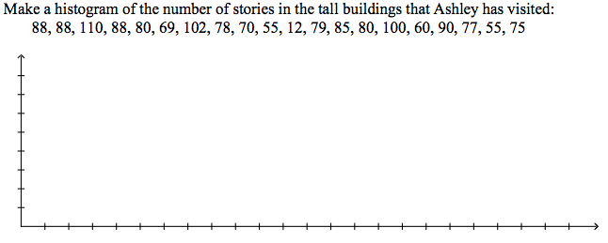
4.

5. Label the following as Mean, Median or Mode:

The average 100-meter time at the meet was 12.3
His batting average put him in the middle of his team
Most serious car accidents among teens involve males

Find the mean, median, mode, and range for each data set.
6. number of students helping at the cookie booth each hour: 3, 5, 8, 1, 4, 11, 3

7. weight in pounds of boxes loaded onto a semi truck: 201, 201, 200, 199, 199

8. car speeds in miles per hour observed by a highway patrol officer: 60, 53, 53, 52, 53, 55, 55, 57

9./10. The following are test scores from a math class.
60, 64, 68, 68, 72, 76, 76, 80, 80, 80, 84, 84, 84, 84, 88, 88, 88, 92, 92, 96, 96, 96, 96, 96, 96, 96, 100, 100
a. Create a histogram of the test scores. Use intervals of 10.
b. Find the mean, median and mode

