Name: ___________________________ Date: ___________ Period: ________

Secondary Math II 13-3 Homework
Volumes of Cylinders, cones and spheres

Find the volume of each figure.

1. A Cone with a radius 2 meters and a height of 9 meters.

2. A sphere with a radius of 17 mi.

3. A cylinder with a diameter of 9 in and a height of 16 in.

4. A cylinder with a diameter of 6 in and a height of 13 in.

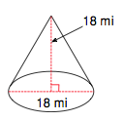
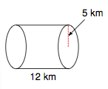
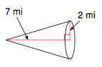
5. 6. 7.

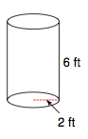

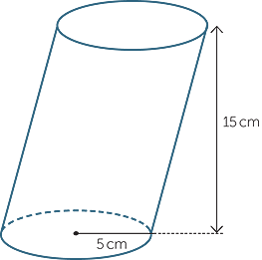
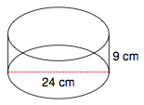
8. 9. 10.

