**Secondary Math I** Name: ________________________________

13-3 Isosceles & Equilateral Triangles Homework

1 – 2 Circle all that are true

1. Isosceles triangles have:

a. Two equal sides b. Three equal sides c. Two equal angles

d. Three equal angles e. Equal base angles

2. Equilateral triangles have:

a. Two equal sides b. Three equal sides c. Two equal angles

d. Three equal angles e. Equal base angles

Fill in the missing information

3. Vertex angle: __________

B

4. Base angles: _____________________

5. Measure of leg 1/2: ________________

11

C

A



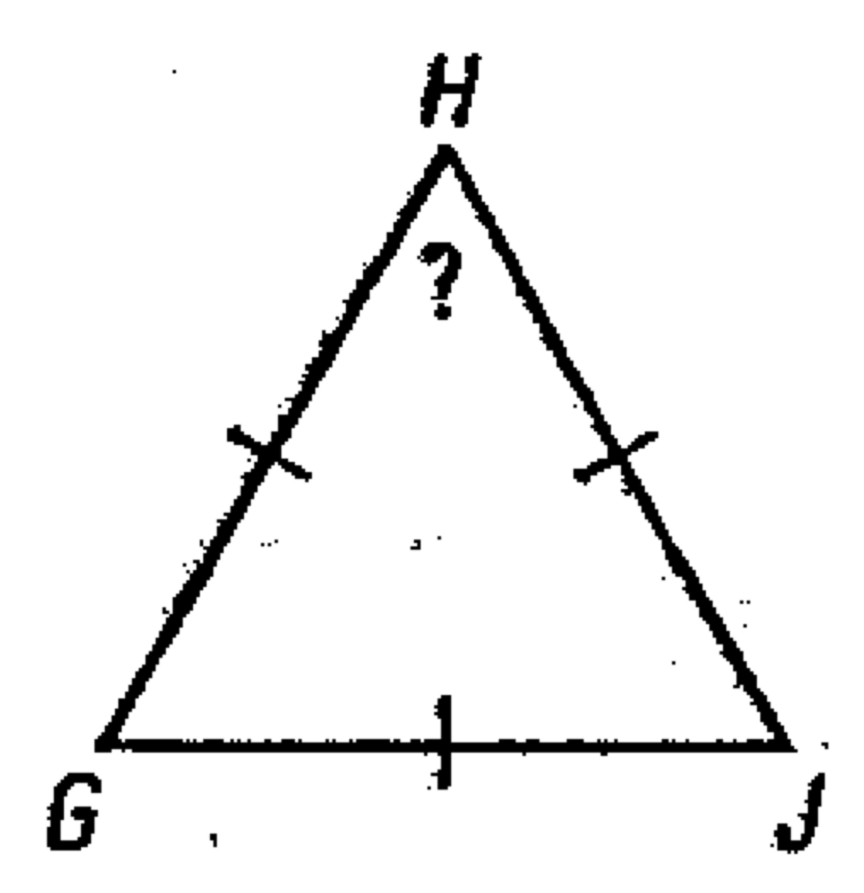6. Find the unknown measure(s).

7. Solve for x and y 8. Solve for x and y

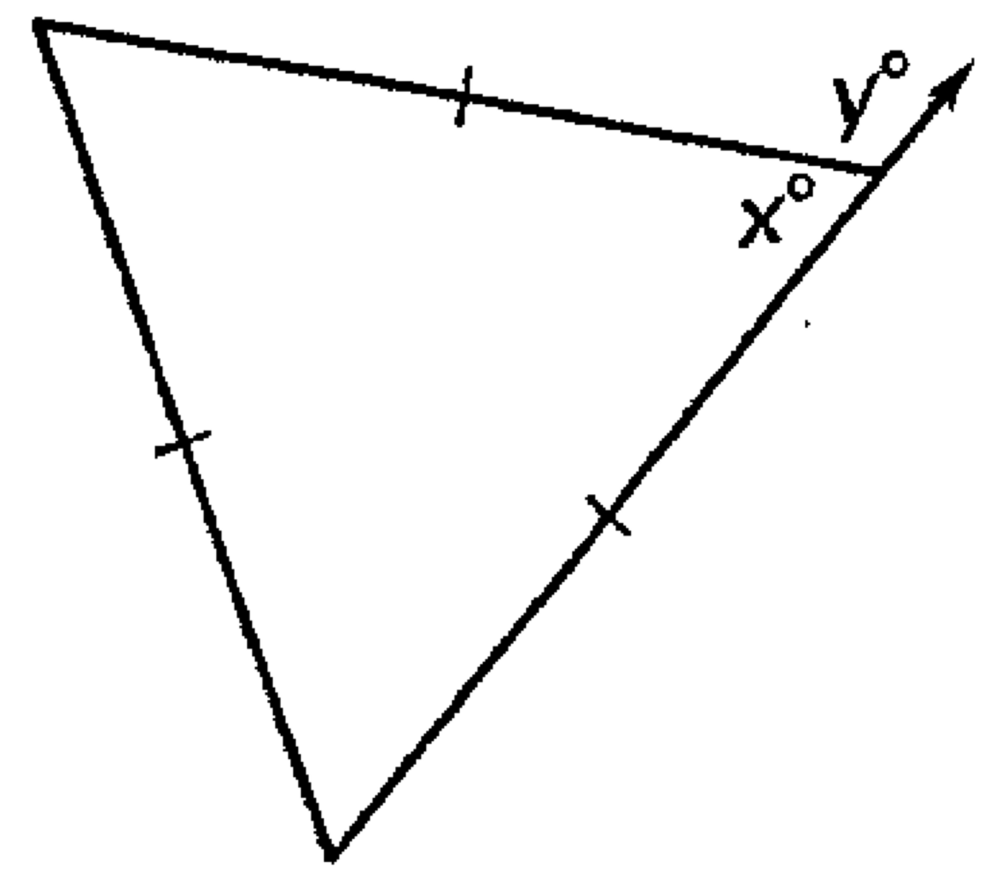

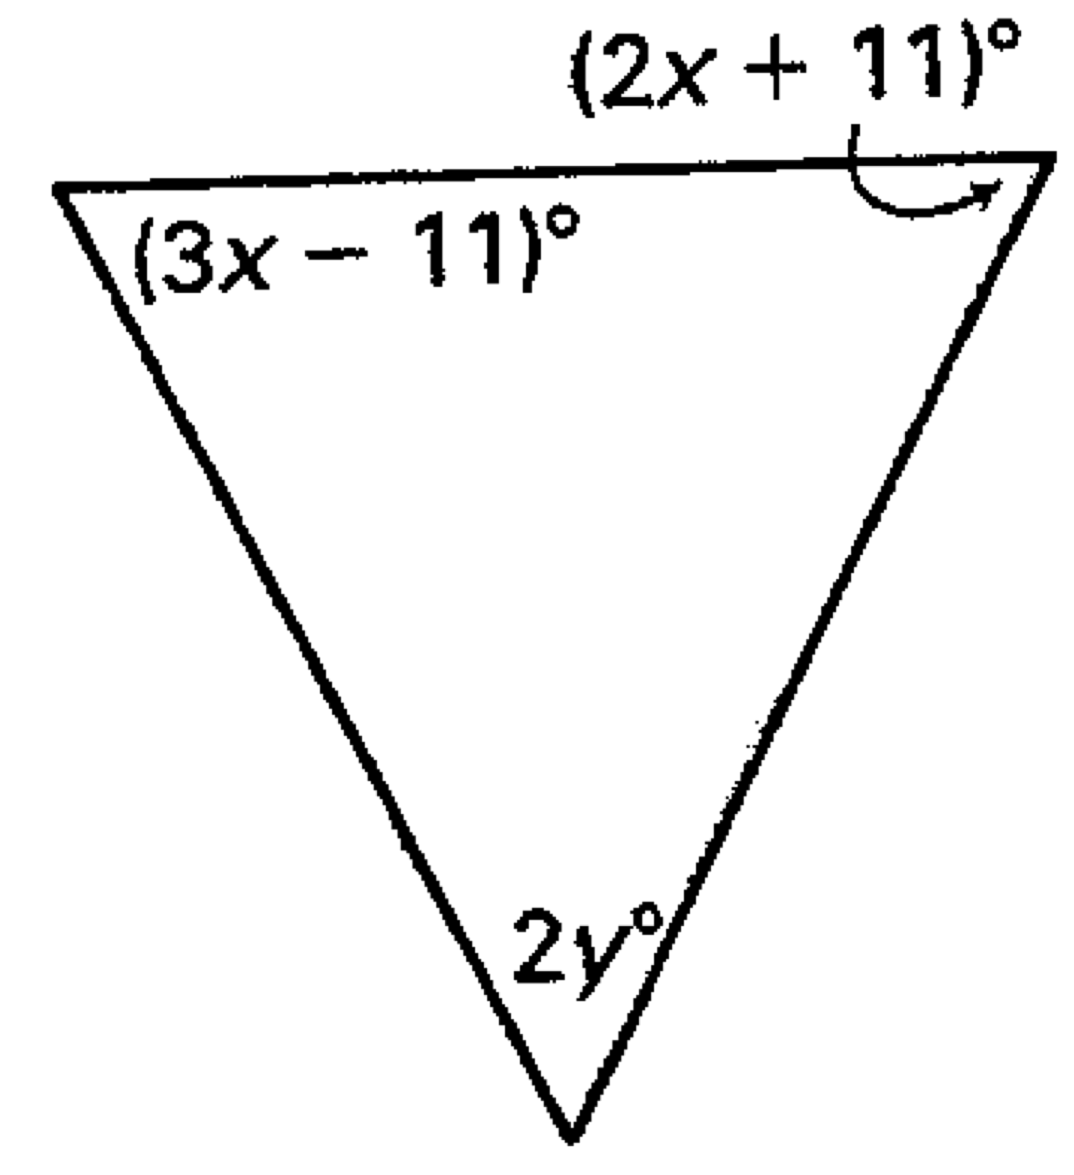

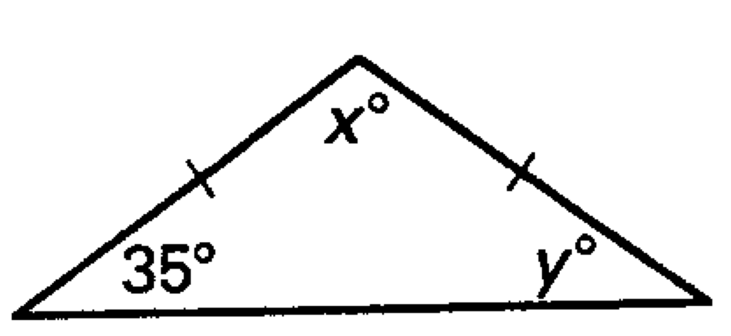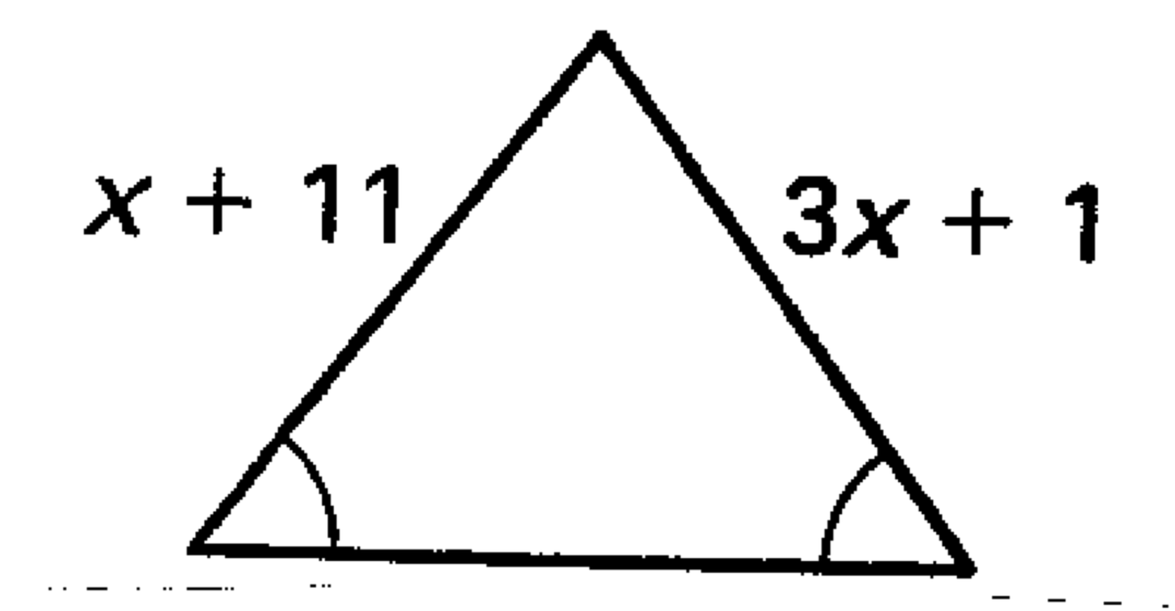9. Find the measure of the legs 10. Solve for x and y