Name: ___________________________ Date: ___________ Period: ________

# Secondary Math II 13-2 Homework

**More circles**

Find the radius and the diameter

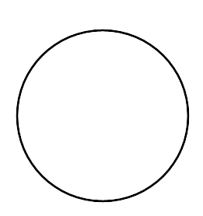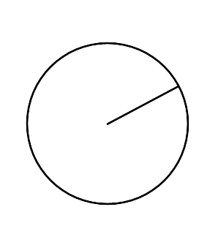1. 2. 3.

r=6cm C=14π mi A = 25π ft

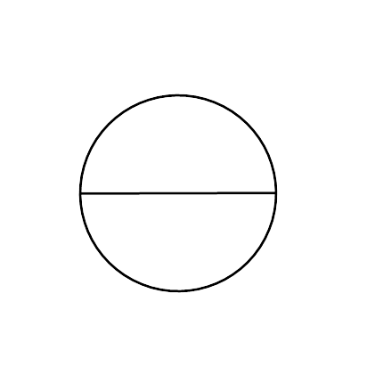Find the area and the circumference



4. 5. 6.

C=16π ft d=5mi C=24πm

**Find **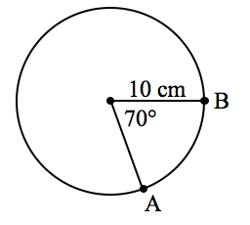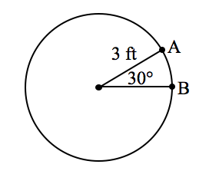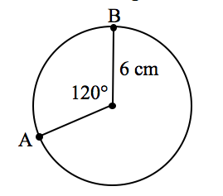

7. 8. 9.

Find the area of the shaded region. Round answer to the nearest tenth. Don’t forget units!!!

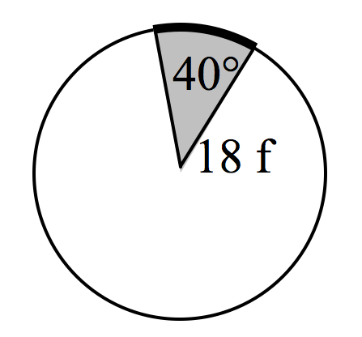

10.