**Secondary Math I** Name: ________________________________

13-2 Congruency Theorems HW Date: _________________ Class: _________

State what congruence postulate can be used to prove that the triangles are congruent.

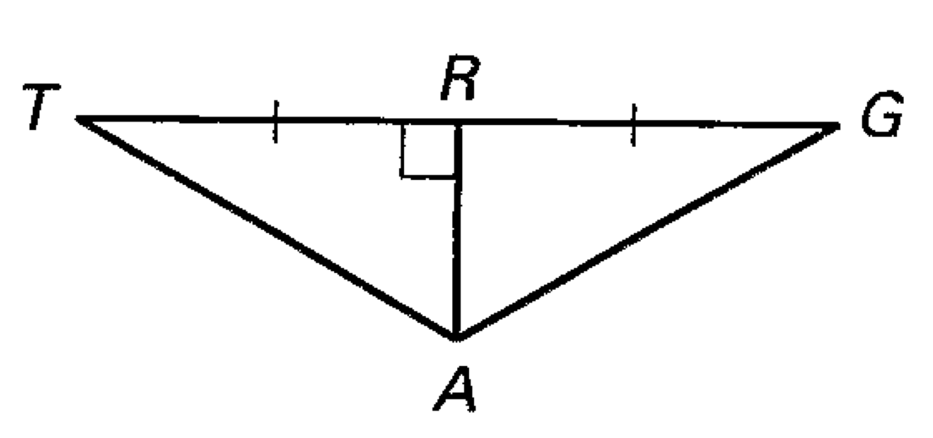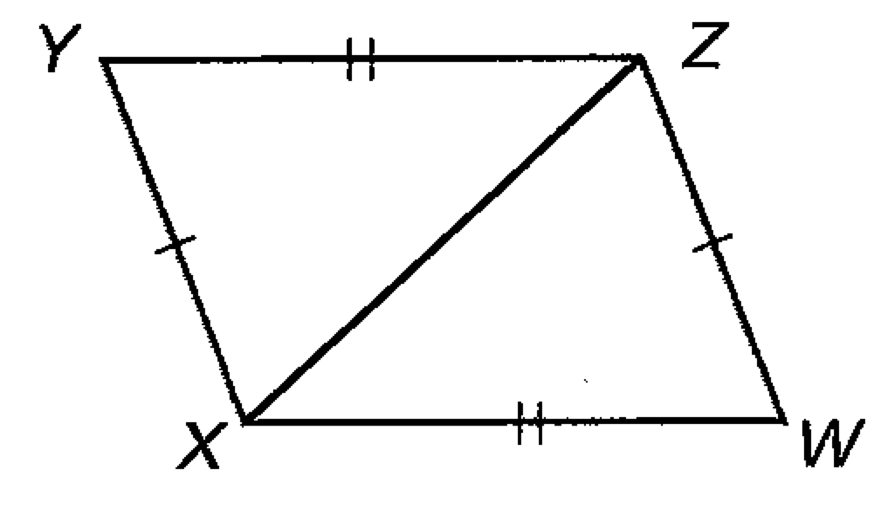 1.  2. 

State the third congruence that must be given to prove that  using the indicated postulate or theorem.

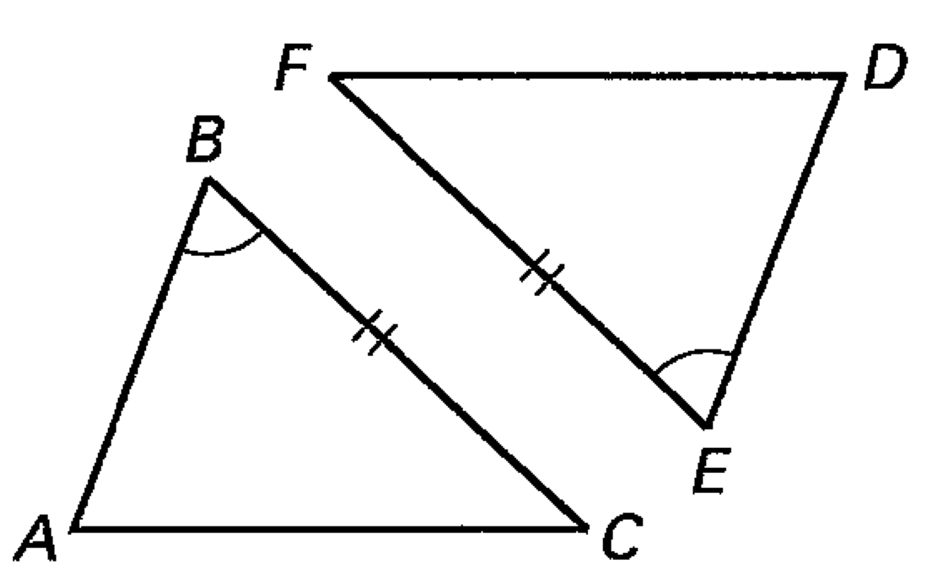 3. ASA Congruence Theorem 4. AAS Congruence Theorem

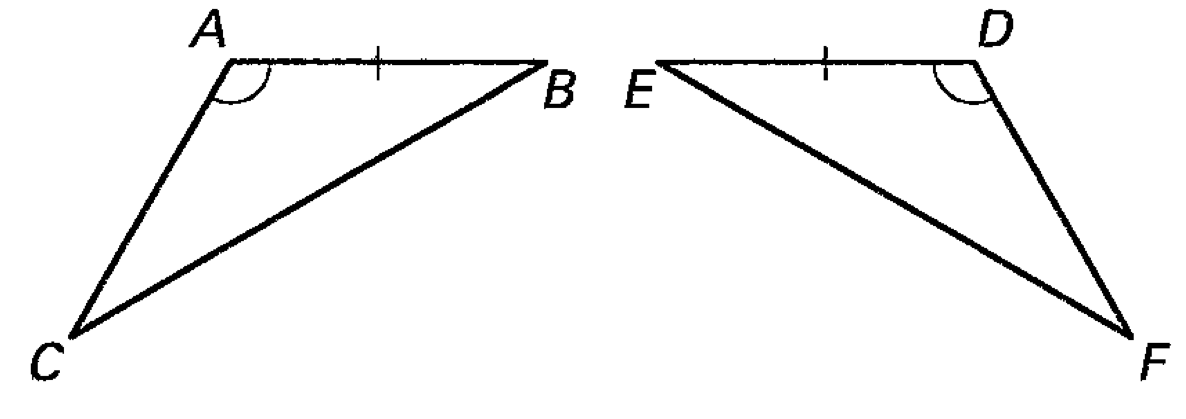

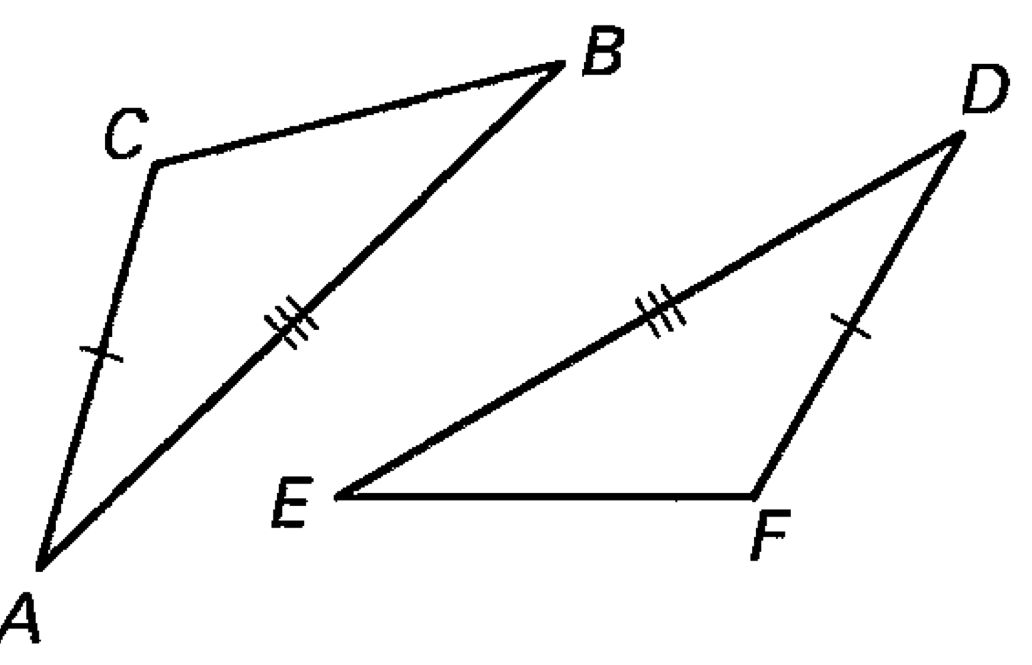5. SSS Congruence Theorem 6. SAS Congruence Theorem

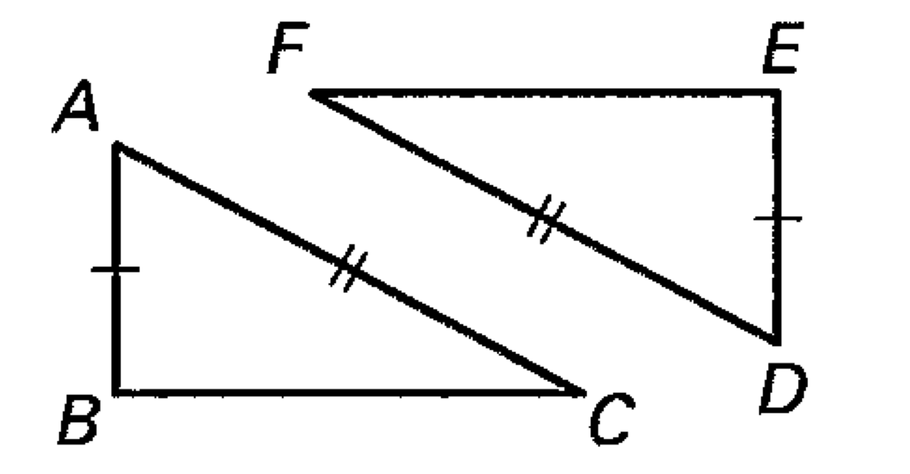

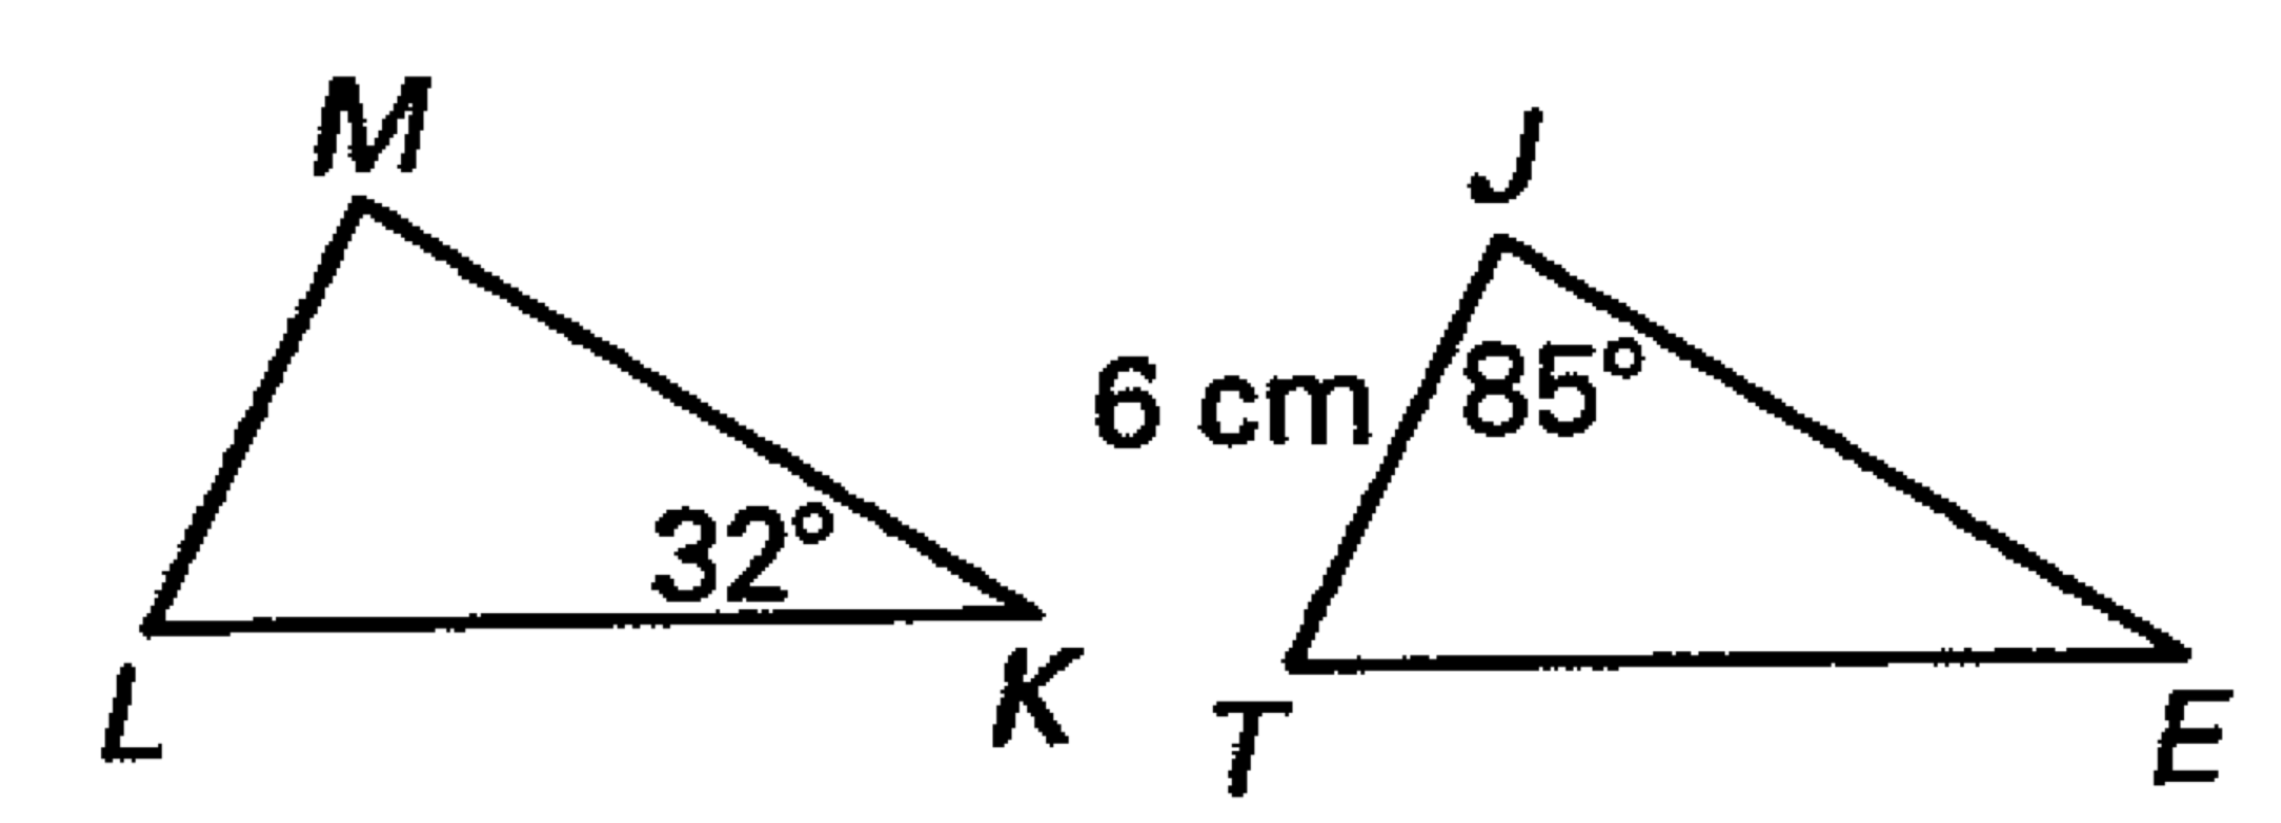

7. If ** then 

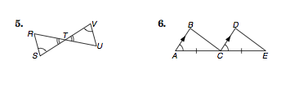What corresponding parts must be congruent to prove the triangles are congruent by the ASA Postulate?