Name: ___________________________ Date: ___________ Period: ________

# Secondary Math II 13-1 Homework

**Equations of Circles and Graphing**

Write the standard form of the equation of each circle whose information is given.

1. Center: (-2, 4) 2. Center: (1, 0)

Radius: 6 Radius: 2

3. Center: (0, 0) 4. Center: (-3, -4)

Radius: 3 Radius: 

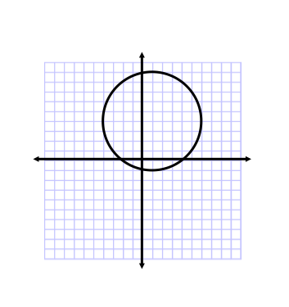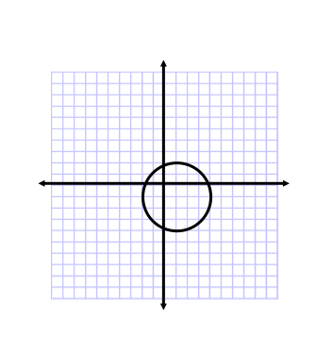Find the center and radius of each circle. Write the standard form of the equation.

5. 6.

Graph each given the standard form of the equation.

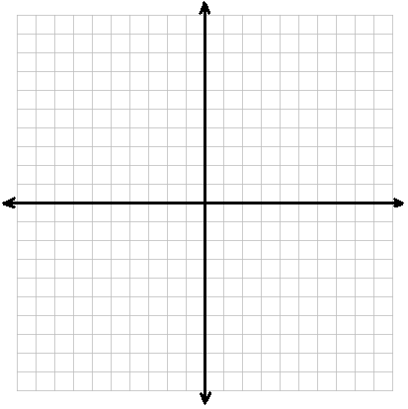7.  8. 

9.  10. 

