Name: ___________________________ Date: ___________ Period: ________

Secondary Math II 12-1 Homework
Fundamental Counting Principle and Multiplying Probability

1. A bag contains 4 white cards, 3 black cards, and 7 red cards. Find the probability of each event for one draw:

A white card A black card

Calculate the probability of each event for one roll of a 6 sided die:

2. A one, A four 3. A number greater than 6, a number less than or equal to 6

Find the total number of license plates possible :

4. A letter followed by 3 digits followed by 2 letters, Six digits

Draw a tree diagram for the following situations, and find the total possible number of outcomes:
5. A student wants to get involved in one of each extracurricular activity:
Sports: track, football, volleyball
Arts: choir, band
Academic Clubs: science, math

6. An airline’s records show that its flights from Los Angeles to Dallas arrive on schedule 92% of the time. They also show that its flights from Dallas to Miami leave on schedule 97% of the time. If you fly from Los Angels to Miami with a connection through Dallas, what is the probability that you will arrive at Dallas and leave from Dallas at your scheduled times?

Events A, B, C and D are independent, and P(A) = 0.5, P(B)=0.25, P(C)=0.75, and P(D)=0.1. Find each probability.

7. P(A and B) 8. P(A and C)

Refer to the spinner shown below in which each numbered section is exactly of the circle. Find the probability of each event in three spins of the spinner.
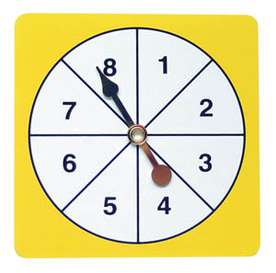
9. All three numbers are 3 or greater than 5.

10. All three numbers are 4 or less than 6.

