Name: ___________________________ Date: ___________ Period: ________

# Secondary Math II 11-3 Homework

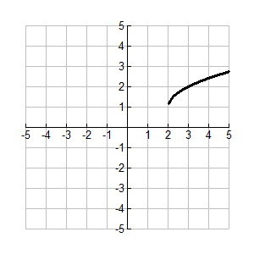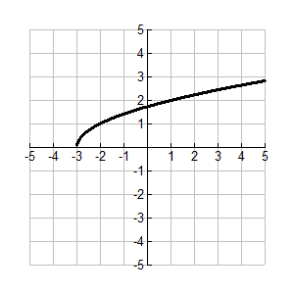**Root Functions**

Write the function from the given graph.

1. 2.

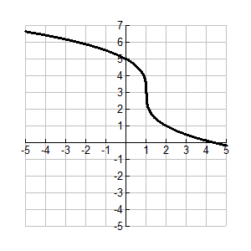Function: Function:

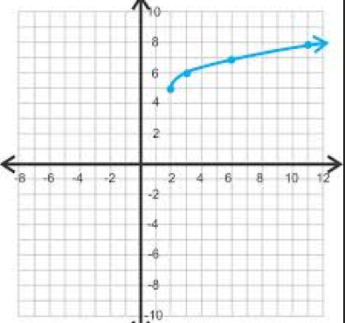3. 4.

Function: Function:

Sketch the graph of the given function.

5.  6.

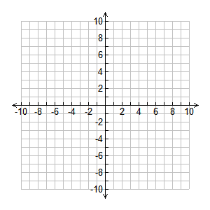

7.  8.

9. 10. 