Name: ___________________________ Date: ___________ Period: ________

# Secondary Math II 11-2 Homework

**Inverses**

*Write the inverse of the function. Determine if the function is one-to-one.*

1. 

*Determine whether the function is one-to-one.*

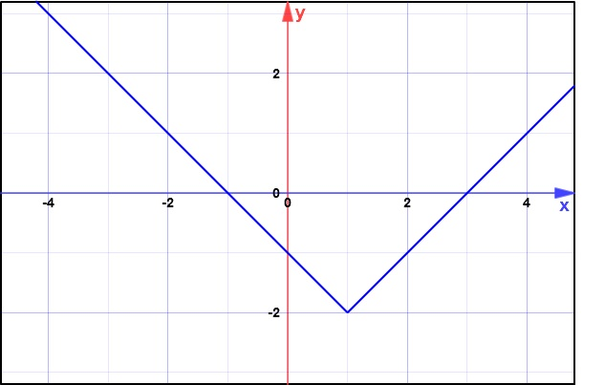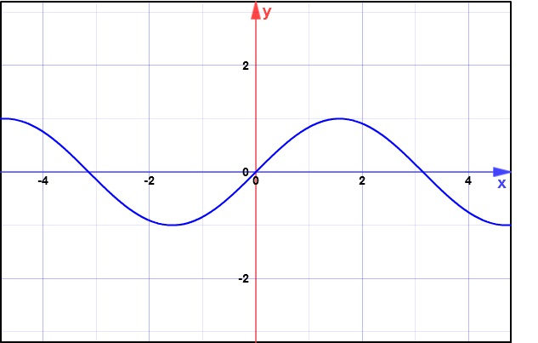2. 3.

*For each function, find an equation of the inverse.*

4.  5.  6. 

*Verify, using composition, that the following are inverses.*

7.  8.  9. 

*Find the inverse of each function. Then verify, using composition that they are inverses of each other.*

10. 