Name: ___________________________ Date: ___________ Period: ________

# Secondary Math II 10-4 Homework

# Quadratic Inequalities

Write the inequality using interval notation. Graph the inequality.

1.  2. 

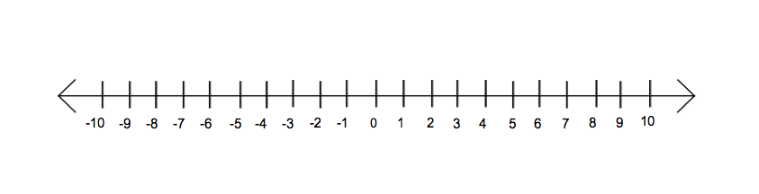

3. 



Write the inequality using set notation in terms of x. Graph the inequality.

4.  5. 



Solve the following inequalities. Graph your solution. State your solution in set and interval notation.

6.  7. 



8.  9. 

