Name: ___________________________ Date: ___________ Period: ________

# Secondary Math II 10-1 Homework

# Review of Linear Equations

1. Define *linear*.

2. a. What is *slope-intercept* form?

b. What do *m* and *b* represent?

**Identify the slope and y-intercept, then graph the linear equation.**

3.  4.  5. 

m = ________ b = ________ m = ________ b = ________ m = ________ b = ________



**Write the equation of the line in slope-intercept form.**

6. m=3, b=-6 7. m=1, b=0

**Write the equation for the graph.**

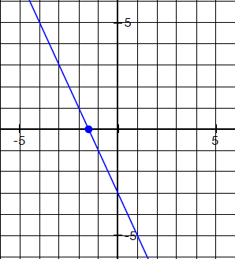8.

**Solve each system by graphing.**

9.  10. 

